Building a Vision System to Inspect Circuit Boards

Overview
A board inspection system is a camera station on the production line that photographs every board, compares it with what a correct board should look like, and sorts it into pass, fail, or "a person should look at this". In the electronics industry this is called AOI (Automated Optical Inspection). Mobile phone boards are the hardest case of it: parts are tiny (some are 0.4 × 0.2 mm), packed tightly, and the solder joints are shiny, so the same design works for almost any electric board if it works for phone boards.
The system has five parts, and each one matters as much as the AI model:
- Imaging hardware — camera, lens and, above all, lighting. A defect the camera cannot see clearly cannot be found by any model.
- Alignment — lining up each photo with the board's design data so the software knows exactly where every component should be.
- Inspection logic — a mix of simple measurements, AI models trained on good boards, and AI models trained on known defects.
- Decision and review — clear pass/fail, plus a "review" bucket for uncertain cases that a human checks.
- Learning loop — every human review becomes new training data, so the system gets better week by week.
The rest of this document walks through each part in order. The diagram below shows how they connect.
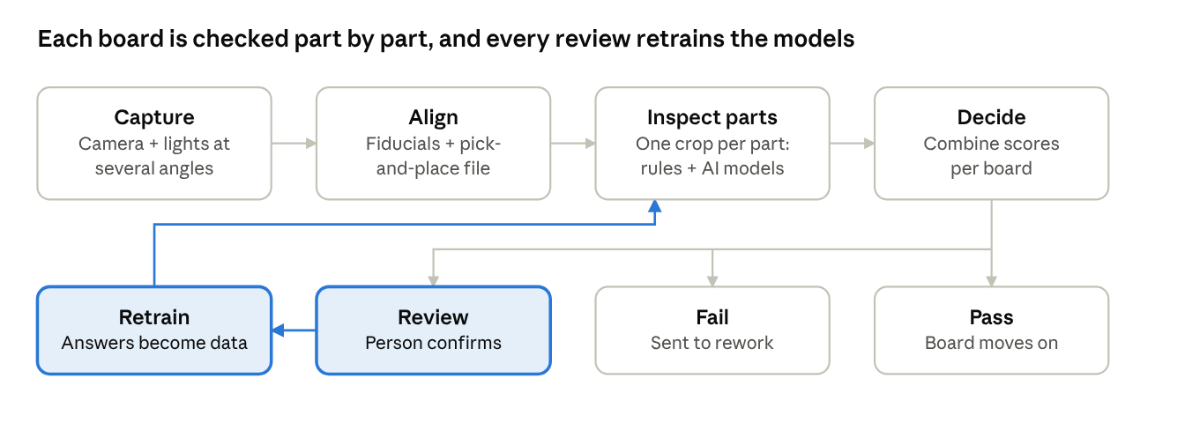
inspection station · 4 main steps, 3 outcomes, 1 learning loop
The top row runs once per board in seconds; the coloured loop runs every week or two, turning operator decisions on uncertain cases into better models.

What to look for, and where on the line
Decide first which defects you must catch and at which production step, because that decides the camera, the lighting and the model. A board is usually checked at several points; catching a problem early is cheaper than catching it at the end.
Inspection point | What the board looks like here | Typical defects | Needs 3D height?
Bare board (before assembly) | Copper tracks and pads only | Open track, short between tracks, missing hole, "mouse bite" (nibbled edge), spur, extra copper | No
After solder paste printing (called SPI) | Grey paste deposits on pads | Too little / too much paste, paste smeared, paste shifted off the pad | Yes — paste amount is a volume
After placement, before oven | Parts sitting on wet paste | Missing part, wrong part, rotated or shifted part, reversed polarity | Helpful, not required
After reflow oven (main AOI) | Finished solder joints | Solder bridge (two pins joined), too little solder, tombstone (part standing on one end), lifted pin, solder balls, missing / wrong / reversed part | Yes, for lifted pins and solder shape
Final / cosmetic | Complete board | Scratches, dirt, foreign objects, damaged connectors, bent pins | No
Two honest limits to know up front:
- Hidden joints. Chips like BGAs have their solder balls underneath the package. No normal camera can see them; factories use X-ray for those. An optical system can only check that the chip is present, aligned and correctly marked.
- What counts as a defect. Use the industry standard IPC-A-610 (acceptability of electronic assemblies) as your rulebook. It defines, with pictures, how much solder or how much offset is acceptable. Without a written rule, two people label the same joint differently and the model learns confusion.
A practical starting scope for a phone-type board: the post-reflow station, checking missing / wrong / shifted / reversed parts, solder bridges and insufficient solder. That covers most of the defects that cause real failures.

Hardware: camera, lens, lighting, motion
Spend most of your early effort here. Good images make a simple model look brilliant; poor images make the best model useless.

Step 1 — Work out the resolution you need
The rule: the smallest thing you must see should cover at least 3 to 5 pixels. One pixel is just a dot of colour; you need several to see a shape. So first find your smallest feature (for example, the gap between two pads where a solder bridge could form), then compute the pixel size and how much board one photo covers:
- Pixel size = smallest feature ÷ (3 to 5)
- Field of view = pixel size × number of pixels across the sensor
Worked example: the smallest gap you care about is 0.05 mm (50 µm). Divided by 5, you need about 10 µm per pixel. A 20-megapixel camera has about 5,500 pixels across, so one photo covers 5,500 × 10 µm ≈ 55 mm. A phone board larger than that is photographed in several tiles by moving the camera (or the board) and stitching the tiles together. For larger parts only (0603 and bigger), 20–25 µm per pixel is usually enough, and one photo covers far more.

Step 2 — Choose the parts
Part | What to choose | Why
Camera | Industrial "area-scan" camera, 12–25 MP, global shutter, USB3 or GigE | Global shutter takes the whole image at once, so movement does not smear it. Colour helps tell solder from copper; monochrome gives sharper detail and is common when you capture under several coloured lights instead.
Lens | Telecentric lens (best) or a high-quality fixed lens | A normal lens sees tall parts from an angle near the image edges, so their sides block the view of nearby joints. A telecentric lens looks straight down everywhere, so sizes and positions stay true across the whole image.
Lighting | Multi-angle ring light (several rings at different angles) plus, ideally, a coaxial light | Solder is a curved mirror. Light from a low angle reflects off its sloped sides; light from straight above reflects off flat tops. Taking 2–4 photos under different angles turns solder shape into visible patterns. The classic AOI trick: red light from above, green from the middle, blue from low, in one colour photo — the colour at each point tells you the slope of the solder there.
3D height (optional, later) | Structured light (projected stripe patterns) or laser line triangulation | Needed for paste volume, lifted pins and solder fillet height. Add it when 2D results plateau.
Enclosure | Black, closed box around camera and board | Room lighting changes during the day. Blocking it makes images repeatable.
Motion | Conveyor with a stop, or an XY gantry for tiling; board clamp | The board must sit still and flat; a warped board goes out of focus.
Trigger | Sensor that detects the board, plus a controller (PLC or microcontroller) that fires lights and camera together | Strobing the light only during exposure gives brighter, sharper, repeatable images.
Computer | Industrial PC with an NVIDIA GPU, or an NVIDIA Jetson-class box for a compact station | Runs the models fast enough to keep pace with the line.
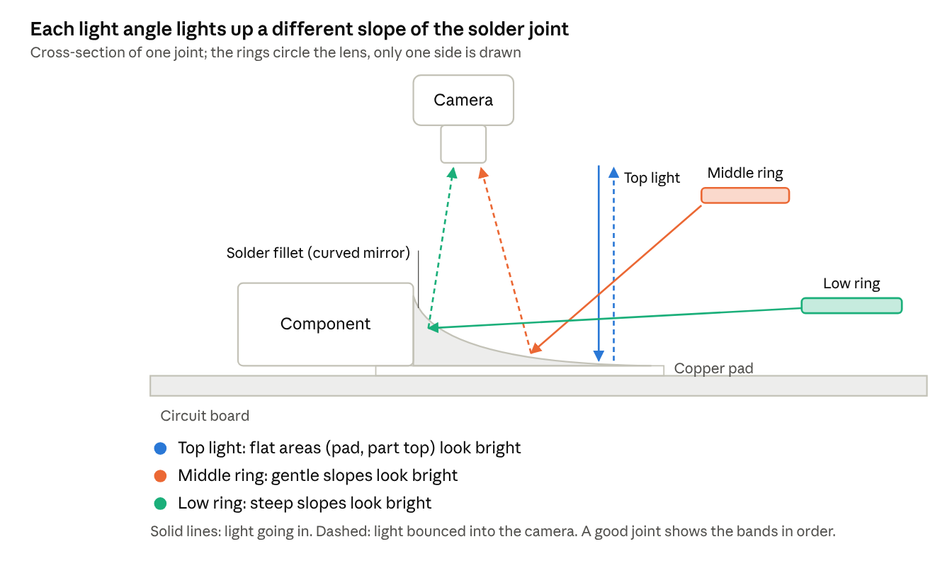
how light angles reveal solder shape · cross-section
Solder acts like a curved mirror, so the camera only sees light that hits a surface tilted just right to bounce it upward. Because each light angle lights up a different tilt, the photos under the three lights together describe the joint's shape: a missing colour band means too little solder, an unexpected one means a bridge or a lifted pin.
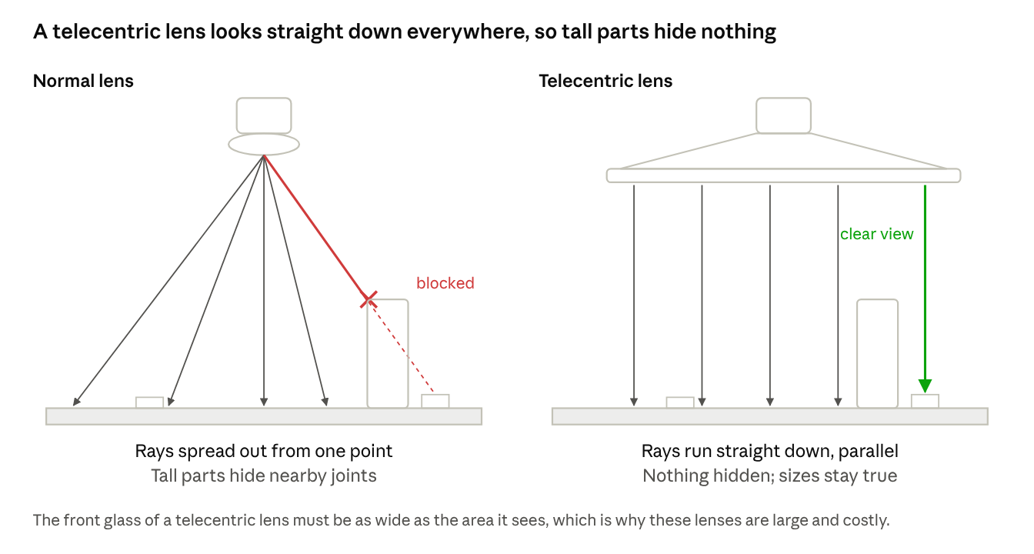
normal lens vs telecentric lens · side view
With a normal lens, a part near the edge of the image is seen at an angle, so a tall capacitor can hide the small joint next to it, and a part's apparent size changes with its height. A telecentric lens removes both problems, which is why it is worth its price on dense phone boards.

Step 3 — Test before you buy everything
Borrow or rent a camera and a few lights, photograph 20 good boards and 20 known-bad ones, and look at the images yourself. If you cannot see the defect clearly on screen, change the lighting before writing any software. Most camera and lighting vendors will do a free sample test with your boards.

Mechanical design and hardware in detail
This section goes one level deeper into the physical station: how it is built, how the board is moved and held, how the camera is moved and mounted, and how it is wired, controlled and made safe. The drawing shows where each part sits.
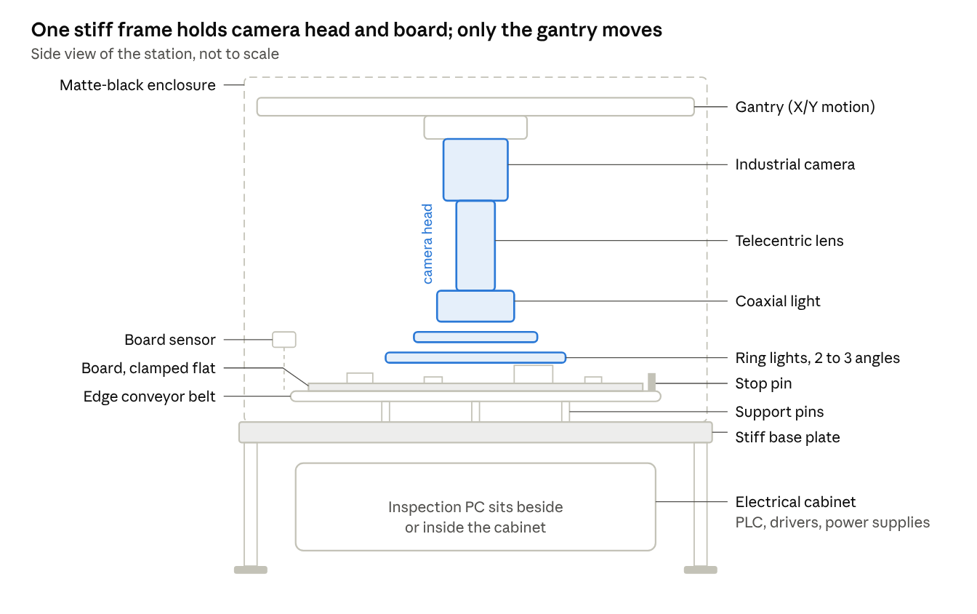
inspection station · side view, main mechanical parts
Everything that affects the image (camera, lens, lights) is one rigid camera head, and both the head and the board are tied to the same stiff base plate, so nothing can shift relative to anything else.

Frame, enclosure and board handling
The mechanical job of the station is simple to say and hard to do well: put every board in the same place, flat and still, for the moment the photo is taken — every time, for years. Any wobble, tilt or drift shows up in the images as false alarms.
Frame (the skeleton).
- Build from aluminium extrusion profile (40 × 40 mm or 45 × 45 mm, with T-slots) for the outer frame. It is easy to cut, bolt and change while prototyping.
- For the part that carries the camera and gantry, use a stiff base plate (thick aluminium tooling plate, or a granite or steel plate on high-end machines). The camera and the board must not move relative to each other; mounting both to one stiff plate is the simplest way to guarantee that.
- Add diagonal braces. An open rectangle of profile can twist like a parallelogram; one diagonal per side stops it.
- Stand the station on levelling feet with rubber pads, and keep it off the same bench as presses, pick-and-place machines or anything that shakes. Vibration during exposure blurs fine detail. A simple test: put a glass of water on the base plate while nearby machines run — visible ripples mean you need better isolation (rubber mounts or a heavier base).
Enclosure (the dark box).
- Close the imaging area on all sides with opaque panels (black anodised aluminium, black acrylic or powder-coated sheet). Inside surfaces should be matte black so light does not bounce around and create reflections on shiny solder.
- Leave slots only where the board enters and exits, and hang black brush strips or flaps over them to block outside light.
- Fit hinged access doors with safety interlock switches so the motion stops when a door opens.
- Plan airflow: lights, camera and PC produce heat, and temperature changes make metal expand and focus drift. Use a small filtered fan pushing air in (slight positive pressure keeps dust out) and a vent opposite.
Board handling (moving the board in and holding it).
Part | What it does | What to look for
Edge conveyor | Two narrow belts carry the board by its edges (the standard on SMT lines) | Belt width standard for SMT (usually a few mm edge support), smooth speed control, antistatic belts
Width adjustment | Moves one conveyor rail to fit different board widths | A lead screw with a hand wheel is fine at first; a motorised one lets the software set width per product
Board sensors | Detect board arriving, at the stop, and leaving | Small photoelectric (light-beam) sensors; one before the stop to slow down, one at the stop
Stop pin | A small pin that rises to stop the board at the imaging position | Pneumatic or solenoid-driven; it gives a rough position, alignment software does the fine correction
Clamping | Holds the board firmly once it has stopped | Side clamps that push the board against a fixed rail, or a top clamp along both edges
Board support | Stops thin boards from sagging in the middle | Support pins or a lifting plate under the board; vacuum support for very thin boards
Why flatness matters so much. A good lens has a small depth of field — the range of heights that are sharp — often well under 1 mm at high magnification. Phone boards are thin and can bow after the oven. If the middle of the board sags or bows by more than the depth of field, part of the image goes soft. Support pins or vacuum under the board, plus clamping at the edges, keep it inside the sharp zone. A telecentric lens helps further because it keeps sizes correct even when the height changes slightly.
For a first bench prototype you can skip the conveyor entirely: a machined pocket or pins on a plate that the board drops onto (a "nest" or fixture) gives excellent repeatability for very little money. Add the conveyor when you move to the line.

Motion system for photographing in tiles
If one photo covers the whole board, you need no motion beyond the conveyor — the simplest and most reliable design. If the board is bigger than one field of view (common at 10 µm per pixel), you move the camera and lights together over a still board, taking a grid of overlapping tiles. Moving the camera is usually better than moving the board: the board stays clamped and flat, and only the lighter camera head moves.
The usual layout is an XY gantry: a bridge that moves front-to-back (Y axis) on two rails, with a carriage that moves left-to-right (X axis) along the bridge, carrying the camera, lens and lights. A Z axis (up-down) is optional; add a small motorised one if you need to refocus for different board thicknesses or tall parts.
Part | Options | Recommendation and why
Linear guides (the rails) | Profiled rail with ball carriages; round rods with bushings | Profiled rail (for example 15 mm size). Much stiffer and more accurate; round rods flex and wear.
Drive | Ball screw; toothed belt; linear motor | Ball screw for a first build — accurate, stiff, easy to understand. Belts are faster and cheaper but stretch slightly. Linear motors are fastest and most precise, at a much higher cost.
Motor | Stepper motor; closed-loop stepper; servo motor | Closed-loop stepper or servo. A plain stepper can silently skip steps; then every tile after that is in the wrong place. Closed-loop motors detect and correct this.
Position feedback | Motor encoder; linear scale on the rail | A motor encoder is enough at first, because the alignment software corrects small errors. Add a linear scale if stitching errors appear.
Homing | Limit / home switches on each axis | Required. The gantry needs a known zero position at power-up. Use precise inductive or optical home sensors.
Cable carrier | Plastic "drag chain" | Routes camera, light and motor cables so they move without bending sharply or rubbing. Use high-flex cables rated for continuous motion; normal cables break inside after months of movement.
How accurate does the motion need to be? Two things matter:
- Repeatability (returning to the same spot each time) matters more than absolute accuracy, because each tile is aligned in software anyway. Aim for a repeatability of a few pixels or better — at 10 µm per pixel, about ±20 µm is comfortable, which a ball screw and profiled rail achieve easily.
- Overlap between tiles. Plan 10–20% overlap so the software can match tiles together using the image content and fiducials, and so no part is ever cut in half without being fully visible in at least one tile.
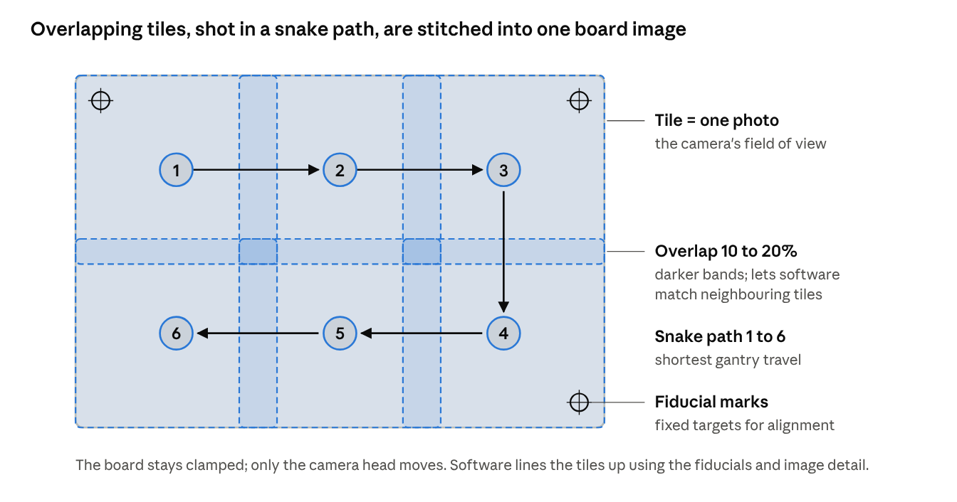
tile scanning · 6 tiles with overlap, snake path
Six tiles cover this example board. The darker bands are where neighbouring photos overlap; software uses the shared detail there to join them without gaps or seams.
Stop-and-shoot or shoot-while-moving?
- Stop-and-shoot: move, wait for vibration to settle (typically tens of milliseconds), take the photos, move on. Simple and sharp; start here.
- Shoot while moving: fire a very short, bright light flash while the gantry keeps moving. Faster, but the flash must be short enough that the movement during it is tiny:
- Blur = speed × flash (exposure) time
- Keep the blur below half a pixel
Example: at 10 µm pixels you want blur under 5 µm. Moving at 100 mm/s (= 100,000 µm/s), the flash must be shorter than 5 ÷ 100,000 s = 50 microseconds. That needs strong strobed LEDs and a hardware trigger from the motion controller at exact positions ("position-compare output"), so it belongs in a later version.

Camera head: mounting, optics, lighting and calibration parts
The camera, lens and lights travel together as one camera head. Design it as a single rigid block so their positions relative to each other never change.
Camera and lens mounting.
- Mount the camera by its body to a stiff bracket, and support a long or heavy lens (telecentric lenses can be long and heavy) with a second clamp near its front. Hanging a heavy lens from the camera's small screw thread lets it droop and slowly shift focus.
- Point the camera straight down. Include a small tilt adjustment (two or three fine screws) to make the sensor exactly parallel to the board; a tilted sensor gives a sharp image on one side and a blurry one on the other.
- Set focus with a fine Z adjustment (a manual micrometer stage at first) and then lock it. Fixed focus and fixed aperture give images that stay identical for months; motorised focus is only needed for boards of very different thickness.
- Leave the lens aperture slightly closed (a middle f-number) — this widens the depth of field at the cost of needing more light.
Working distance. This is the gap between lens front and board. Choose a lens with enough working distance (typically 60–150 mm) to fit the ring lights between lens and board and to clear the tallest component on the board.
Lighting hardware.
Light | Mounted how | Shows best
Coaxial light | A box with a half-mirror between lens and board, light sent straight down along the lens axis | Flat shiny surfaces: pads, chip tops, markings; flat solder looks bright
Multi-tier ring light | Two to four rings at different angles (high, middle, low) around the lens, each switchable or a different colour | Solder slopes and fillet shape; low ring makes edges and raised parts stand out
Dome light | Half-sphere with a diffuse white inside, camera looking through a hole at the top | Even, shadow-free light on very shiny or curved parts; hides glare
Low-angle bar lights | Lights almost flat to the board from the sides | Scratches, dust, raised edges, lifted pins
Practical points:
- Use a dedicated LED light controller with trigger inputs, so each light group can be strobed for exactly the camera exposure and its brightness set by software. Strobing also lets LEDs run brighter for short pulses without overheating.
- Brightness drifts as LEDs age and warm up. Keep the calibration target (below) in the station so the software can check and compensate brightness every shift.
- Bring the cable from each light group and the camera trigger to one controller so all timings come from one clock.
3D height module (when you add it). Structured-light systems use a small projector mounted at an angle (often two or four projectors from different sides to avoid shadows behind tall parts) that projects stripe patterns while the camera photographs them; the bend of the stripes gives height. The projectors must be bolted rigidly to the camera head and calibrated together with the camera. Buying a ready-made 3D sensor module is usually far easier than building one.
Calibration parts to keep in the station.
- Calibration plate: a glass or ceramic plate printed with a precise dot or checker grid. Used to measure the exact µm-per-pixel, correct lens distortion and calibrate tile positions.
- Grey or white reference card: for flat-field and brightness correction.
- Golden board: a known-good production board kept safely, used to check the whole system after any change or maintenance.
- A good practice is a small fixed calibration target mounted on the station beside the conveyor, so the gantry can image it automatically at start-up.

Electrical, control, line connection, safety and computing
Who controls what. Split the work between two "brains":
- A PLC or motion controller handles everything that must happen at exact moments: conveyor, stop pin, clamps, gantry moves, and firing the lights and camera together. It is reliable and keeps working even if the PC is busy.
- The inspection PC handles images, models, decisions, database and the operator screen. It tells the controller "next board", "move to tile 3", and receives "photos taken".
For a bench prototype, a microcontroller board plus stepper/servo drivers can replace the PLC; move to an industrial controller for the line.
Power and wiring.
- Use a 24 V DC industrial power supply for sensors, valves and the controller; give motor drivers and lights their own supplies so motor current spikes cannot flicker the lights.
- Put everything in a separate electrical cabinet (or a closed section of the station) with terminal blocks, labelled wires and a main switch.
- Keep motor cables physically apart from camera and sensor cables, and use shielded cables for motors — motor drives create electrical noise that can corrupt camera data.
- A small UPS (battery backup) on the PC avoids corrupted files and lost results during power dips.
Connecting to the production line.
- SMT lines pass boards from machine to machine using a simple handshake standard called SMEMA ("I have a board ready" / "I am ready to receive"), a few signal wires between neighbouring machines. Your station must speak it to sit in the line. The newer IPC-HERMES-9852 standard does the same over a network and also passes the board's ID.
- A barcode or 2D-code reader (or reading the code from your own image) identifies each board so results can be stored against its serial number and sent to the factory's MES.
- A reject path: the downstream handshake can hold failed boards, or add a small reject buffer/diverter so failed boards are pulled out of the line.
Safety (do not skip).
- Emergency stop button on the front, wired to cut motor power through a safety relay (not just a software command).
- Door interlock switches that stop the gantry and conveyor when a door opens.
- Guards over moving belts and pinch points; no exposed gantry while running.
- ESD (static) protection: connect the frame, conveyor and board support to ground, use antistatic belts, and give operators a wrist-strap point. Phone boards are easily damaged by static.
- If the station will be sold or used in a regulated factory, follow your region's machine safety rules (for example CE marking in Europe); a safety engineer review is worth it.
Computer and storage.
- An industrial PC with a recent NVIDIA GPU, enough RAM for a full board of images (32–64 GB), and a fast NVMe SSD.
- If you use GigE cameras, give each camera its own network port (a dedicated network card, possibly with Power over Ethernet), not a shared office network.
- Plan storage carefully — images are big. A 20 MP monochrome image is about 20 MB uncompressed. Four lights × six tiles = 24 images ≈ 480 MB per board. At thousands of boards per day, that fills disks in days. Common practice: keep full images only for failed and reviewed boards, keep the small component crops for everything flagged, and keep only results for passed boards (plus a random sample for audits).
Parts checklist
Group | Items
Structure | Aluminium profile frame, stiff base plate, braces, levelling feet with anti-vibration pads
Enclosure | Matte-black panels, access doors with interlocks, light-blocking brushes at slots, filtered fan and vent
Board handling | Edge conveyor with width adjustment, board sensors, stop pin, edge clamps, support pins or vacuum plate, (prototype: fixture plate)
Motion (if tiling) | Profiled linear rails, ball screws, closed-loop steppers or servos with drivers, home switches, drag chains, high-flex cables
Camera head | Industrial camera, telecentric lens, rigid bracket with tilt and fine focus adjustment, lens support clamp
Lighting | Coaxial light, multi-tier ring light (and/or dome), LED strobe controller
3D (later) | Structured-light projector(s) or ready-made 3D sensor
Calibration | Dot-grid calibration plate, grey/white reference card, golden board, fixed on-station target
Control and electrical | PLC or motion controller, 24 V supplies (separate for motors and lights), safety relay, e-stop, terminal blocks, shielded cables, UPS
Line interface | SMEMA (or HERMES) connection, barcode reader, reject buffer or diverter
Computing | Industrial PC with GPU, NVMe storage, dedicated camera network card, operator monitor for the review station
ESD | Grounding of frame and conveyor, antistatic belts, wrist-strap point

Cost estimate
A bench prototype costs roughly $8,000 in parts, and a full in-line station roughly $30,000–40,000, before engineering time. For comparison, commercial AOI machines are commonly quoted at $50,000 to over $200,000, with one industry article citing a mid-range system at about $100,000 plus roughly $10,000 a year for maintenance and software.
How to read the table: prices are in US dollars, rounded, for one unit. Prices found in euros or pounds were converted roughly (€1 ≈ $1.15, £1 ≈ $1.33). Rows marked estimate are typical ranges, not a quoted price — get supplier quotes before buying. Hardware prices have moved a lot in 2026 (GPUs and NVIDIA Jetson boards in particular went up), so treat every figure as a starting point.
Part | Bench prototype | In-line station | Price evidence
Industrial camera, 20 MP | $1,500 | $2,500 | Estimate. Example model: Basler ace 2, 20.2 MP; smaller 5 MP ace 2 models list for about $700 at Edmund Optics
Lens | $1,100 (entry telecentric) | $3,000 (high-resolution telecentric) | Edmund SilverTL telecentric from about €995; PlatinumTL £1,696–4,246; GoldTL €4,585 (catalogue prices)
Lighting (ring + coaxial, later dome) | $600 | $3,500 | Budget: Moritex ring lights from $415, coaxial from $135. Industrial: Balluff 100 mm ring light about $1,620, Balluff coaxial €1,063–1,537
LED strobe controller | $350 | $1,900 | Basler SLP strobe controller €299; Gardasoft 4-channel Triniti controller €1,670
Motion (XY for tiling) | $500 | $6,000 | Hobby-grade 300 mm ball-screw stage with stepper about $90–$150 each, plus drivers. Precision: OptoSigma XY stage from about $2,160, Zaber 300 mm stage €3,355. Larger servo gantry: estimate
Board handling | $200 (fixture plate) | $3,600 | 1 m SMEMA SMT conveyor £1,000–1,950; stop pin, clamps, support pins: estimate
Frame, base plate, enclosure | $600 | $4,000 | Estimate (aluminium profile, tooling plate, black panels, interlocked doors)
Control, power, safety | $300 (microcontroller + supplies) | $2,500 | Siemens S7-1200 CPU 1214C PLC about €240–275 on marketplaces; safety relay, e-stop, power supplies, cabinet: estimate
Computer | $3,000 (desktop + RTX 5080) | $5,000 (industrial PC + GPU) | RTX 5080 street price about $1,425–1,600 (launch price $999). Compact option: Jetson AGX Orin dev kit now $3,499 after a July 2026 price rise
Calibration, barcode reader, cables | $300 | $1,500 | Estimate
Total (parts) | ≈ $8,450 | ≈ $33,500 | Sum of the rows above
3D height module (optional) | — | quote needed | Varies widely by supplier and accuracy; ask 2–3 vendors
Costs the table leaves out: engineering and programming time (usually the largest cost of a home-built system), machining of custom brackets, safety certification if required, spare parts, and the time of the people labelling data and running reviews. A reasonable rule: if you have no in-house automation engineer, budget at least as much for integration help as for parts.
Where to save, where not to. Don't save on lighting, the lens and board flatness — they decide image quality, and image quality decides everything. You can save on motion (one large field of view with no tiling avoids the gantry entirely), on the computer (start with a desktop GPU), and on the conveyor (start with a fixture plate).

Low-cost setups
You do not need the full station to start. The two budget builds below cost about $600–900 and about $2,200, and both are good enough to prove the idea, collect real data and train the first models — phases 1 to 4 of the roadmap. You then upgrade only the parts that turn out to limit you.
The savings come from four choices:
- No conveyor. Load boards by hand into a 3D-printed holder (a "nest"). It gives very repeatable positioning for almost nothing.
- Reuse cheap motion. A budget 3D printer already has an XY gantry with stepper motors, home switches and a controller. Bolt the camera where the print nozzle was, and send it G-code moves ("go to X, Y") from Python to shoot tiles.
- Hobby electronics instead of industrial control. A small microcontroller (ESP32 or Arduino) can fire the light and the camera trigger; a Raspberry Pi can run the camera.
- Use a computer you already have. Training and inspection run fine on an existing desktop with a mid-range GPU.
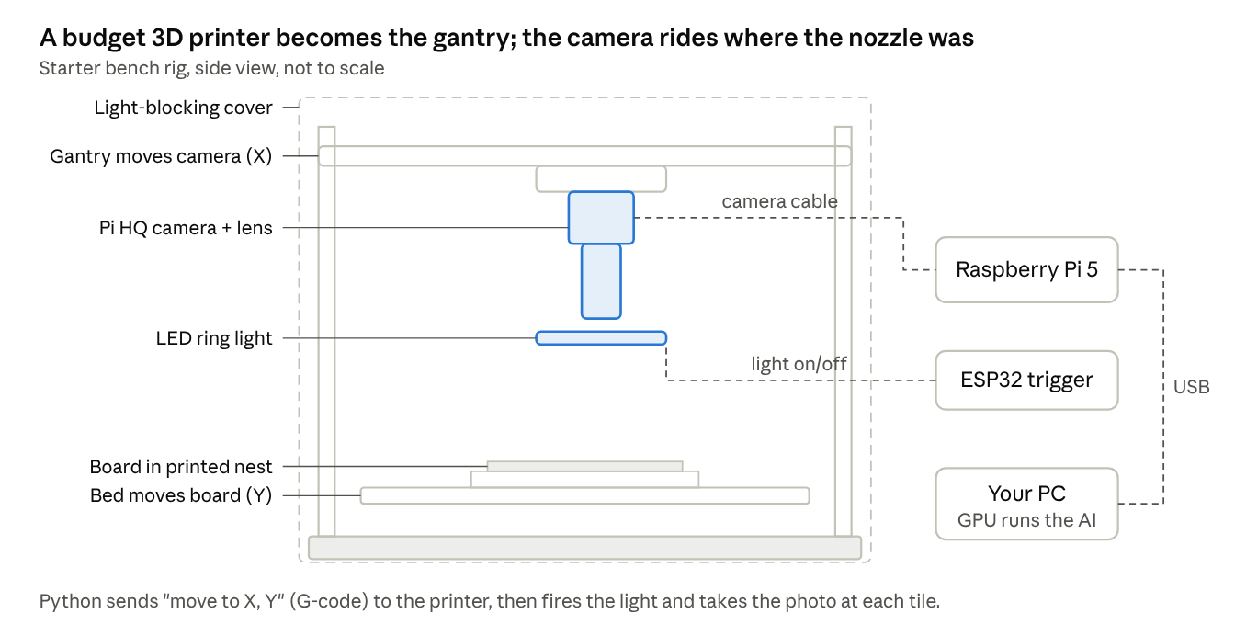
starter bench rig · side view, built on a 3D printer
The printer keeps doing what it is good at, moving accurately to a position, while the camera, light and computer do the inspection.

Option A — Starter bench rig (about $600–900)
Part | What to use | Price | Price evidence
Camera | Raspberry Pi HQ Camera (12.3 MP, accepts standard C-mount lenses) | $60 | Listed around $50–64
Lens | 16–25 mm C-mount machine-vision lens (not telecentric) | $60 | Estimate
Camera computer | Raspberry Pi 5 | $100 | Estimate; check current price, memory costs pushed many boards up in 2026
Lighting | LED ring light plus a home-made diffuser (white plastic or a 3D-printed dome) | $50 | Estimate
Motion | Second-hand or budget 3D printer used as the XY gantry | $200 | Estimate; skip it entirely if one photo covers your board
Holder and enclosure | 3D-printed board nest; black foam board or cloth to block room light | $80 | Estimate
Light trigger | ESP32 board plus a MOSFET switch module | $20 | Estimate
Calibration target | Printed dot-grid target (glass target later) | $30 | Estimate
AI computer | Your existing PC; if it has no suitable GPU, a used RTX 3060 12 GB | $0–290 | Used RTX 3060 12 GB averaged about $290 in July 2026
Total |  | ≈ $600 (≈ $890 with the GPU) | Sum of the rows
Will the resolution be enough? Use the rule from the hardware section: each pixel should be 10–15 µm for phone-type boards. The HQ camera is about 4,000 pixels wide, so set the camera height so one photo covers about 40–60 mm of board (4,000 × 12 µm ≈ 48 mm). A phone board then needs a few tiles, which the 3D printer gantry handles.
Settings that matter on cheap cameras: turn off auto-exposure, auto white balance and autofocus, and fix them by hand. Automatic settings change the image from shot to shot, and the AI sees those changes as defects. The HQ camera has a rolling shutter (it reads the image line by line), which is fine here because the board and camera are stopped when you shoot.

Option B — Budget station (about $2,200)
This keeps the same approach but swaps in a real industrial camera, a telecentric lens and proper rails — the three upgrades that improve image quality most.
Part | What to use | Price | Price evidence
Camera | 20 MP USB3 industrial camera from a lower-cost maker (for example Hikrobot MV-CS200-10UM, or a Daheng equivalent) | $550 | Estimate; get quotes. Model details: Hikrobot MV-CS200-10UM
Lens | Compact 0.5× telecentric lens | $340 | Edmund CompactTL 0.5× about NT$10,888; Computar 0.5× telecentric $519–799
Lighting | Budget ring light plus a small coaxial light | $250 | Estimate; branded reference: Moritex ring from $415, coaxial from $135
Light trigger | ESP32 plus MOSFET driver (home-made strobe) | $30 | Estimate, instead of a $350+ commercial controller
Motion | Two hobby ball-screw stages with steppers, plus driver board | $380 | Stages about $90–$150 each; drivers and controller estimate
Frame and enclosure | Aluminium profile frame, black panels | $250 | Estimate
AI computer | Used RTX 3060 12 GB in an existing PC | $290 | Used average about $290
Calibration and cables | Glass dot target, USB3 cables | $100 | Estimate
Total |  | ≈ $2,190 | Sum of the rows
A note on the telecentric lens here: at 0.5× on this camera, one photo covers only about 26 × 17 mm with roughly 5 µm per pixel — very sharp, but a phone board then needs about a dozen tiles. If that is too slow, use a normal 25 mm lens for a wider view and accept the angle effect near tall parts.

What you give up, and when to upgrade
You give up | Why it is acceptable at first | Upgrade when
Speed (manual loading, slow tiling) | You are collecting data and testing models, not keeping up with a line | You start shadow mode on the production line
Some image quality (cheaper lens and lights) | Phase 2 tells you if defects are visible; if they are, the parts are good enough | A defect type is hard to see even for a person on screen
Industrial robustness (hobby boards, no safety interlocks) | It sits on a bench with a person present | The station runs unattended or near operators
Line connection (no SMEMA, no barcode reader) | Boards are loaded by hand anyway | It goes in-line
The rule for spending: upgrade the part that limits results, one at a time. In practice the first upgrade is almost always lighting, then the lens, then the camera — the software you wrote carries over unchanged.

The software pipeline, step by step
The key idea: don't ask one AI model to look at the whole board and find everything. Instead, use the board's design data to cut the photo into small pieces — one per component — and check each piece with the right tool. Small, focused checks are far more accurate and much easier to debug.
- Capture. Take the photos for each board (one per lighting setup, and one set per tile if the board is bigger than one field of view). Stitch tiles into one board image.
- Correct the image. Remove uneven brightness with "flat-field correction" (photograph a blank white card once, then divide every image by it), and fix colour balance. This makes a board photographed at 8 am look the same as one at 8 pm.
- Align the board. Every board has small round copper targets called fiducials in its corners. Find them (simple template matching works well), then compute the shift, rotation and slight stretch that maps this photo onto the reference coordinates. After this step, "pixel (x, y)" means the same spot on every board.
  - Why it matters: boards never sit in exactly the same place on the conveyor. Without alignment, every comparison is off by a few pixels, and a few pixels is the size of a defect.
- Load the design data. The assembly line already has a pick-and-place file (centroid file): for every component, its name (like R12 or U3), part number, x / y position and rotation. Combined with the alignment, this tells you exactly where every part should be in the photo.
- Cut out regions of interest (ROIs). For each component, crop a small window around it (the body plus its pads and joints). A phone board may give 500–1,500 crops. Also crop each solder joint separately if you want to judge joints individually.
- Check each crop. For each component crop, run a few targeted checks:
  - Presence — is there a part at all?
  - Right part — does it look like the expected part (size, colour, printed marking read with OCR)?
  - Position — how far is it shifted or rotated from where it should be? Measured in micrometres and compared with the IPC limit.
  - Polarity — is the polarity mark (dot, notch, stripe) on the correct side?
  - Solder — is each joint good, insufficient, bridged or missing?
- Scan the whole board for anything unexpected. Separately, run a general "does this look normal?" model over the full board to catch things not tied to any component: a stray screw, a scratch, a blob of solder in an empty area.
- Decide. Combine the scores into one of three answers per board: pass, fail (clear defect), or review (the system is unsure). Using three buckets instead of two lets you keep missed defects near zero without flooding operators with false alarms.
- Report and record. Save the images, the crops that were flagged, the scores and the decision to a database, and send the result to the factory's tracking system (MES) using the board's barcode. These records become your next training data.
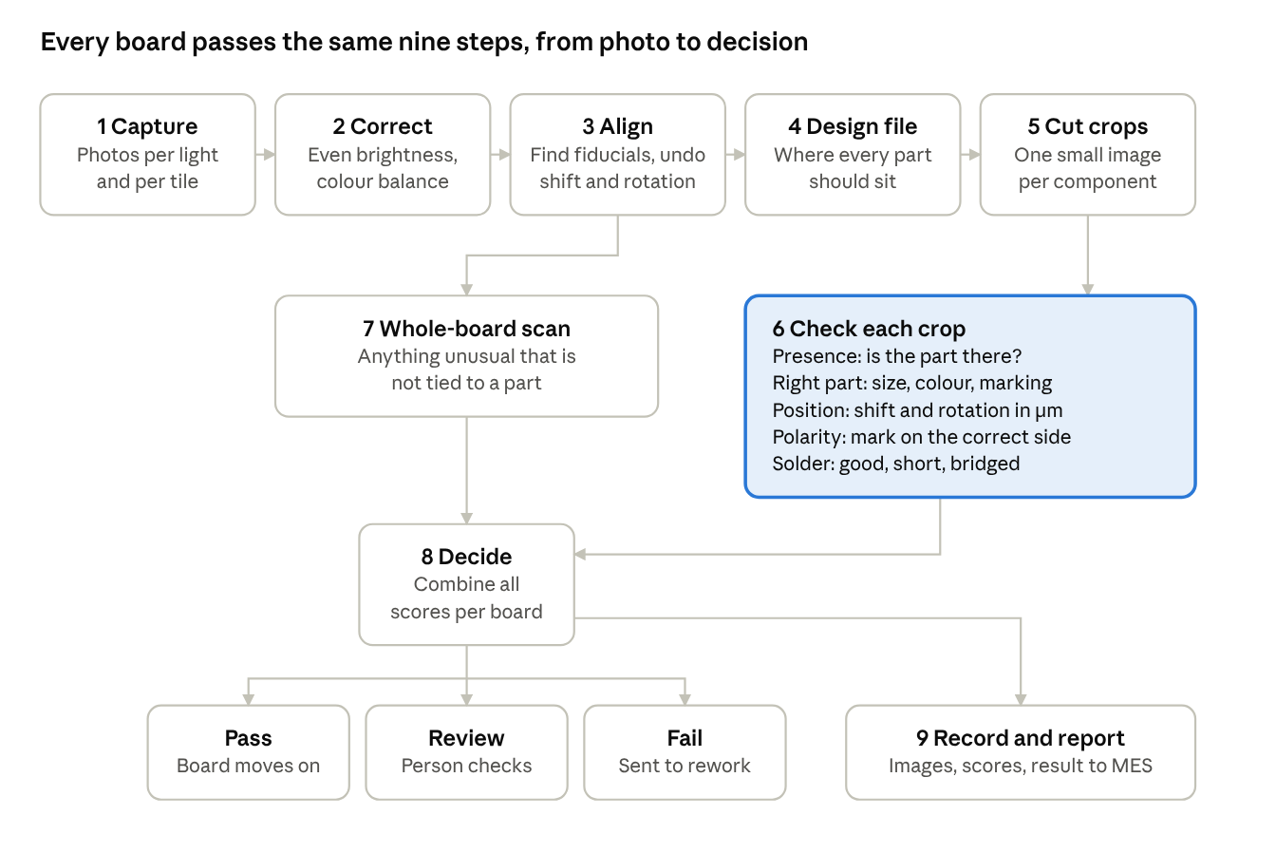
software workflow · 9 steps, 3 outcomes
The per-crop checks (step 6, highlighted) do most of the work; the whole-board scan runs alongside them on the aligned image to catch loose objects and scratches that belong to no component.
Steps 3–5 are what make phone-board inspection work. They turn "find a tiny flaw somewhere in a 50-megapixel image" into "is this 200 × 200 pixel crop of capacitor C47 normal?" — a much easier question.

Choosing the AI and non-AI methods
Use three kinds of methods together, each where it is strongest. The biggest practical fact behind this choice: defects are rare. A good factory may produce one defect per thousands of joints, so you will have huge numbers of good images and very few bad ones, especially at the start.
Method | Trained on | Best for | Weak at
Classical image processing (template matching, colour thresholds, edge measurement, blob counting) | Nothing — you write the rules | Measuring offset and rotation, finding fiducials, checking polarity marks, reading markings | Breaks when parts from a new supplier look slightly different
Anomaly detection (PatchCore, PaDiM, EfficientAD) | Good images only | Catching any defect, including types you have never seen; works from day one | Also flags harmless differences (a different-coloured capacitor); does not say what the defect is
Supervised detection / classification (YOLO-family detectors, CNN or ViT classifiers, segmentation models) | Labelled examples of each defect type | Naming the defect precisely (bridge vs insufficient vs tombstone), fewer false alarms once trained | Needs many labelled defect examples; misses defect types it never saw

How anomaly detection works (the most useful method early on)
Take PatchCore as the example, since it is simple and strong:
- Feed many good component crops through a pretrained network (for example a ResNet or DINOv2). Instead of one answer per image, keep the network's internal description of every small patch of the image — a list of numbers (a "feature vector") describing that patch's texture and shape.
- Store a large set of these good-patch vectors in a "memory bank" (thinned out so it stays fast).
- For a new crop, compute the vector for each of its patches and find the nearest good patch in the memory bank. If even the closest good patch is far away, that patch looks like nothing seen on a good board — it is suspicious.
- The distances form a heat map over the crop showing where the problem is, and the largest distance is the crop's anomaly score. Above a threshold → flag it.
This is the same idea as nearest-neighbour search on DINOv2 embeddings, just applied to small patches instead of whole images — so an existing DINOv2 + kNN pipeline is a good head start. The open-source library Anomalib packages PatchCore, PaDiM, EfficientAD and others with a common training and testing interface.
Tip: train one anomaly model per component type (all 0402 capacitors together, all of one chip type together), not one for the whole board. Each model then only has to learn what "normal" means for one kind of part, which makes it much sharper.

How supervised models fit in
Once you have collected a few hundred real examples of a defect type (from reviews and rework, see the data section), train a classifier on the component crops with labels such as good / missing / shifted / reversed / bridge / insufficient / tombstone. Because the crops are small and already centred, a modest classifier works well. Use an object detector such as YOLO mainly for the whole-board pass (finding foreign objects, solder balls) where there is no design data to tell you where to look.

Recommended combination
- Classical methods for alignment, position measurement, polarity and OCR.
- Per-component-type anomaly models as the safety net that catches anything abnormal.
- Supervised classifiers added gradually for the common defect types, to name them and cut false alarms.
- The final decision looks at all three: a crop the classifier calls good but the anomaly model finds very unusual goes to review, not pass.
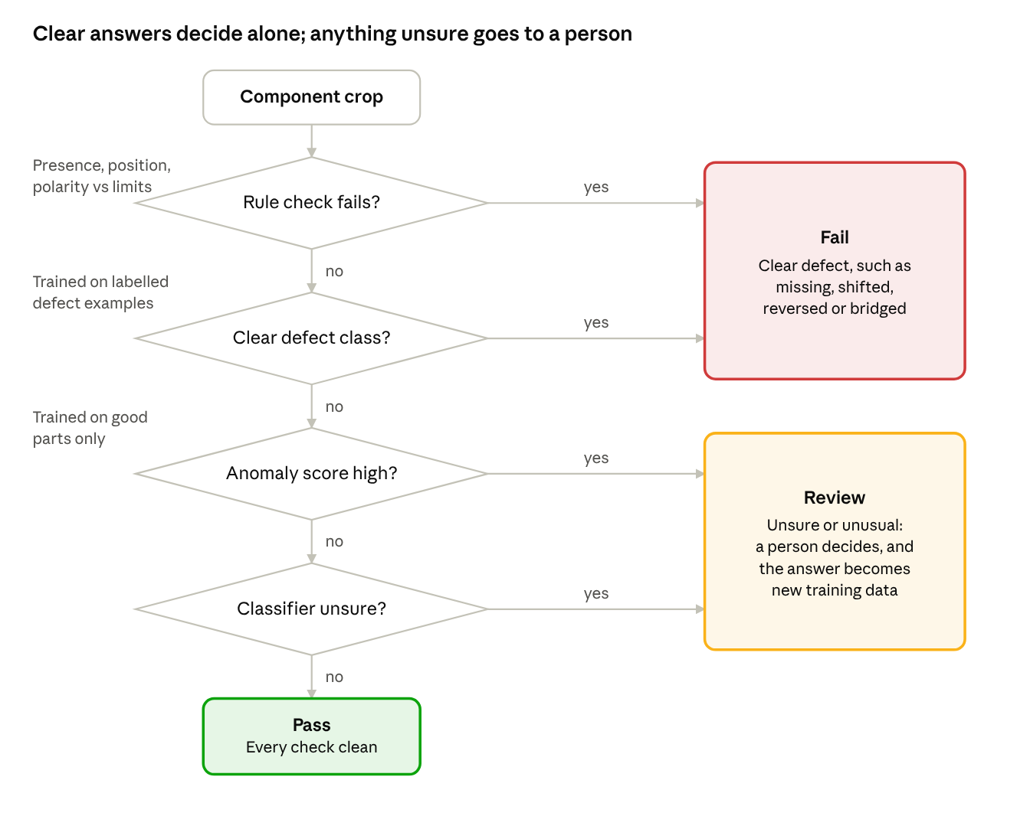
decision flow for one component · 4 questions, 3 outcomes
The order matters: cheap, exact rules go first, the trained classifier names known defects next, and the anomaly model acts as the safety net. A part passes only when every check is clean; any doubt sends it to a person rather than letting it through.

Collecting and labelling data
The good news is that good images are almost free; the work is in getting enough defect examples and labelling them consistently.
Good boards. Photograph at least 50–200 good boards on the real station, spread across different days, production lots and component suppliers. Variety matters more than count: if every training board used capacitors from one supplier, the model will flag the next supplier's slightly different colour as a defect.
Defect examples — four sources, in order of value:
- Real rejects. Ask the rework station to keep (or photograph on your station) every board they repair, and note which component and defect. These are the most realistic examples.
- Defects made on purpose. On scrap boards, remove parts, rotate them, flip polarised parts, bridge pins with a soldering iron, starve a joint of solder. A technician can make hundreds in a day. They are slightly "too clean" compared with real defects, but very useful.
- Synthetic defects. Edit good crops digitally: delete a part and fill in bare pads, paste a part slightly shifted or rotated, copy a real bridge onto another joint. Cheap, unlimited, good for training — but never use synthetic images to measure accuracy.
- Public datasets for practice and early experiments: DeepPCB and the PKU PCB defect dataset (bare-board defects such as opens, shorts, mouse bites, spurs), and VisA, which includes four PCB anomaly-detection sets. They will not match your boards, but they let you build and test the pipeline before your own data exists.
Labelling.
- Use a labelling tool such as CVAT or Label Studio.
- Write a one-page labelling guide with photos for every class, based on IPC-A-610 ("a shift of more than 50% of the pad width is a defect", and so on). Have two people label the same 100 crops and compare; where they disagree, the guide is unclear.
- Because you label per-component crops, most labels are a single word per crop (good, missing, bridge…) rather than drawn boxes — far faster.
Splitting the data correctly. Split into training / validation / test by board (or by lot), never by individual crop. Crops from the same board share lighting and position quirks; if some go to training and some to testing, the test score looks better than reality.

Measuring accuracy and setting thresholds
An inspection system is judged on two numbers that pull against each other, and you need to track both:
- Escape rate — real defects the system passed. These reach customers, so this number must be close to zero.
- False call rate — good parts the system flagged. These cost operator time, and if there are too many, operators start clicking "OK" without looking, which quietly turns false calls into escapes.
In machine-learning terms, with a defect counted as a "positive":
- Recall (share of defects caught) = defects flagged ÷ all real defects
- Escape rate = 1 − recall
False calls are best reported in factory terms — false calls per board (or per 1,000 components) — because that is what operators feel.
Why the threshold is the real control knob. Every model outputs a score, and you choose the cut-off. Lower it and you catch more defects but raise more false alarms; raise it and the reverse. The way to choose:
- On a validation set of boards with known defects, plot recall against false calls for every possible threshold.
- Pick the threshold that catches essentially all defects in the validation set.
- Then look at what is still being falsely flagged and fix the causes (better lighting, more varied good images, a supervised classifier for that part type) rather than raising the threshold.
- Set thresholds per component type, not one for the whole board — a big connector and a tiny resistor behave very differently.
Also test repeatability. Run the same boards through the station 10 times. The decision for each component should be the same every time. If a part flips between pass and fail, the system is sitting on the edge of a threshold, or the board placement or lighting is not repeatable.
Measure per defect type. An overall score can look excellent while one important type (say, reversed diodes) is missed half the time. Keep a table of recall per defect type and per component type.

Running it on the line
Keep up with the line. Measure how many seconds the line spends on each board (its cycle time) and make capture + inspection fit inside it with margin. Speed tips: export models to ONNX and run them with TensorRT on the GPU; run all component crops of one board as a single batch; run capture of the next board while the previous one is being inspected.
Build a good review station. This is where people and the system meet, and it decides whether the system is trusted. For each flagged component, show:
- the crop from this board side by side with the same crop from a reference good board,
- the anomaly heat map on top,
- the component name, defect guess and score,
- two big buttons: real defect / false call (plus a defect type dropdown).
An operator should be able to clear a false call in about two seconds.
Close the learning loop. Every operator click is a free, expert label. Store it with the crop. Every week or two:
- Add confirmed false calls to the "good" set of the anomaly model for that component type (so it stops flagging that look).
- Add confirmed defects to the supervised training set.
- Retrain, test on the held-out boards, and only replace the running model if escapes did not rise and false calls fell. Keep every model version so you can roll back.
Watch for drift. Lights get dimmer with age, cameras get bumped, suppliers change. Photograph a fixed calibration board (or colour target) at the start of each shift and alarm if brightness or position moves beyond a set limit. A sudden jump in false calls on one part number usually means a supplier change.
New products. For each new board design you need its pick-and-place file, its fiducial positions, and 20–50 good boards to teach the anomaly models. Component types already seen on other boards reuse their models, so each new product gets faster to set up.

Roadmap and starter toolkit
Build it in phases, and only move on when the phase's check is met:
- Prototype on public data (1–2 weeks). Train PatchCore with Anomalib on VisA's PCB sets and a YOLO detector on DeepPCB. Check: you understand the pipeline end to end and can read heat maps.
- Imaging test (2–4 weeks). Camera, lens and lights on a bench with your own boards. Check: every target defect is clearly visible to a person on screen, and 10 repeated shots of one board look identical.
- Alignment and crops (2–3 weeks). Fiducial alignment + pick-and-place file → per-component crops. Check: crops land on the correct parts across 50 boards, within a few pixels.
- First inspection (3–6 weeks). Per-component-type anomaly models + classical checks for presence, position and polarity. Check: on a test set with known defects, near-zero escapes, with false calls counted.
- Shadow mode on the line (4–8 weeks). Run beside the existing inspection (people or a commercial AOI) without affecting production; compare every decision and collect labels through the review station. Check: escapes no worse than the current method, false calls at a level operators accept.
- Go live, then improve. Add supervised classifiers as defect examples accumulate, add 3D height if lifted pins or solder volume matter.
↗ roadmap · 6 phases, 5 gates, not to scale
The gates are the point of the plan: skipping phase 2's imaging check is the most common way these projects fail, because every later phase inherits poor images.
Worth knowing: commercial AOI machines from established vendors already do much of this. Building your own makes sense when you need custom checks, lower cost per station, full control of the models, or tight integration with your own data — and a hybrid (commercial AOI plus your own AI review of its flagged images to cut false calls) is a popular, lower-risk first project.
Need | Tools to start with
Camera control | Vendor SDKs (most industrial cameras support the GenICam standard), Harvesters (Python GenICam library)
Classical vision | OpenCV (template matching, alignment, measurement)
Anomaly detection | Anomalib (PatchCore, PaDiM, EfficientAD)
Detection / classification | Ultralytics YOLO, PyTorch with timm models, DINOv2 features
OCR of part markings | PaddleOCR or a small custom classifier for known markings
Labelling | CVAT, Label Studio
Fast inference | ONNX Runtime, NVIDIA TensorRT
Practice datasets | DeepPCB, PKU PCB defect dataset, VisA (PCB1–PCB4)
Defect rulebook | IPC-A-610 standard

